As part of a peace treaty with the Navi, the humans are allowed to mine for Unobtainium in a remote, deserted area of Pandora. The scientists have identified many possible excavation sites, and are now trying to figure out where to place the Mining Center. The placement of the mining center is further constrained by the fact that the robots that will carry the Unobtainium from the excavation sites to the mining center can only walk along pre-specified Grid lines (see figure). The goal is now to find the location of the mining center so that the maximum distance to the excavation sites is minimized. You are to write a program for finding that location.

Specifically, you are given the x- and y-coordinates of the excavations sites, 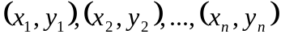 (n denotes the number of excavation sites). You are to find the coordinates for the Mining Center, (x₀, y₀), so that the maximum distances between the mining center and the excavation sites is minimized. All coordinates must be integers. The distance metric to be used is the rectilinear distance (also called Manhattan distance). Specifically, the rectilinear distance between 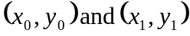 is:

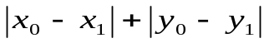

Further, if there are multiple Sites which qualify, then you must find the Site with the x value that is closest to the origin. If two Sites have the x values equally close to the origin, chose the Site with a positive x value.

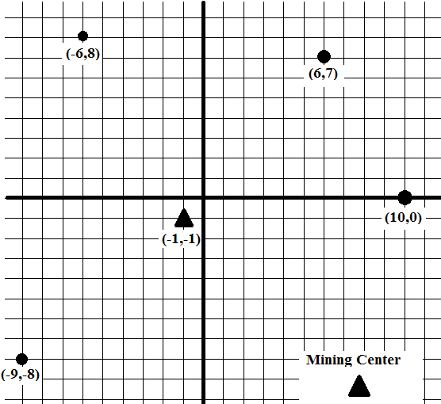

In other words, given the input your goal is to find 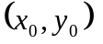 such that:
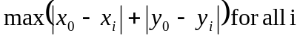 is minimized, and if there are multiple answers, then 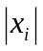is the smallest among all such answers.
You have been given the completed Site class which represents the x- and y-coordinates of excavations sites and the Mining Center.

public class Site
{
private int x;
private int y;

public Site (int a, int b) {
x = a;
y = b;
}

public int getX() { return x; }

public int getY() { return y; }

public void setX(int a) { x = a; }

public void getY(int b) { y = b; }

public String toString() {
return "(" + getX() + ", " + getY() + ")";
}

public boolean equals(Object obj) {
Site loc = (Site) obj;
return getX() == loc.getX()
&& getY() == loc.getY();
}
}

You have been given the incomplete MiningCenter class. You must complete the implementation of the getCenter method which returns the Site so that the maximum distances between the mining center and the excavation sites is minimized.

public class MiningCenter
{
private ArrayList<Site> mines;

/*
* precondition: m.size() > 0
*/
public MiningCenter(ArrayList<Site> m) { mines = m; }

public Site getCenter() {

/* add implementation */

return new Site(0, 0);
}
}

Given the following code fragment:
ArrayList<Site> mines = new ArrayList<Site>();
mines.add(new Site(10, 0));
mines.add(new Site(6,7));
mines.add(new Site(-6,8));
mines.add(new Site(-9,-8));
MiningCenter mc = new MiningCenter(mines);

The following call | returns the following Site
mc1.getCenter() | new Site(-1, -1)

Given the following code fragment:
ArrayList<Site> mines1 = new ArrayList<Site>();
Mines1.add(new Site(0, 0));
Mines1.add(new Site(0, 5));
Mines1.add(new Site(5, 0));
MiningCenter mc1 = new MiningCenter(mines1);

The following call | returns the following Site
mc1.getCenter() | new Site(0, 0)

And Given the following code fragment:
ArrayList<Site> mines2 = new ArrayList<Site>();
mines2.add(new Site(1, -5));
mines2.add(new Site(-10, 5));
mines2.add(new Site(-2, 5));
mines2.add(new Site(10, 10));
mines2.add(new Site(5, -5));
MiningCenter mc2 = new MiningCenter(mines2);

The following call | returns the following Site
Mc2.getCenter() | new Site(2, 5)

